European Court of Human Rights
Council of Europe
F-67075 Strasbourg cedex Date: 24/04/2017
I am writing this letter on behalf of Iraqi’s and Kurdish refugees currently detained in UK detention centres. As you are aware more than 50 Iraqi’s and Kurdish people have been arrested and are being held in different detention centres across the UK. Many of those held in the UK have been resident in the UK for ten to fifteen years and have UK wives, partners and children. To separate them from their families and friends in this way contravenes the Geneva Convention and Human Rights Act. Others have travelled through Eastern Europe and other EU countries and are being held before being deported back to these countries. IFIR has documentary evidence that Iraqi refugees have not been treated well on their journey through Europe and should not be deported back to these countries. Also Please note that we are in the process of making a complaint to the UK Home office regarding the manner Araz Ismael Rasul an Iraqi refugee HO ref R1159213/3 DOB 1 April 1981 was forcibly deported on the 11 April. Araz was bound by hand cuffs on both his wrists and ankles. He was then moved to a toilet inside the plane and spent the duration of the five-hour journey to Amman bound by his ankles and wrists inside the toilet. IFIR has a tape recorded account from Araz recorded during this ordeal.
Some of the Iraqi asylum seekers in Colnbrook Detention Centre who were detained as part of this raid have informed IFIR that they were interviewed by Iraqi officials. Following these interviews they were then cleared for forcible deportation. The UK Government is clearly undertaking this forcible deportation with the agreement of the Iraqi Government, and is using the support of the Iraqi government and its officials to legitimize and authorize the process. It is unacceptable that the UK Government has made such an agreement with the Iraqi Government. We ask you to join with us and strongly condemn this forced deportation by the UK Government at a time when Iraq is in a state of war. The conflict is so great that 164,000 civilians have been displaced in Mosul alone; there is no space in the morgues for the dead in Mosul. The economy is in such a bad state that they cannot afford to pay state workers and as a result of strikes and protests are now only paying a quarter of their workers’ wages. It is this uncertainty and danger that has led so many to attempt to leave Iraq and cross the sea.
The tragedy of refugees on the borders of Europe and in the Mediterranean Sea is a direct consequence of closing borders to people whose livelihoods and homes have been shattered by civil war, unrest and insecurity. The disaster facing refugees places a tremendous responsibility upon European governments. While the UK and other European governments talk about human rights, they have provided no realistic solution to the causes of the current wave of displacement and forced mass migration.
The UK and European countries are ignoring the fact that they are one of the main reasons for the catastrophes leading to the exodus from the Middle East, of which these 50 Iraqis are one small part. The majority of the refugees from Iraq are the direct victims of the political and military involvement of the US and European countries, and their support for repressive regimes and political forces in the Middle East which are so often wrapped up in the garb of democracy. States run by these forces are taking no responsibility for the livelihoods of Iraqi citizens, and in reality have turned Iraqi society into a spiral of conflict between different religious, nationalist and Islamic groups such as ISIS. Iraq is politically and economically insecure and unsafe, and, thanks to the behavior of those in power, its citizens have no chance of a decent life.
IFIR is an organization dedicated to defending human rights, and we see ourselves as a part of a progressive and international movement; we fight for the rights of Iraqi refugees across the world, and work to gain solidarity from human rights organisations worldwide. We ask that you call on the British government to immediately halt these deportations; stop this unlawful agreement with the Iraqi government and release all Iraqi refugees held in detention.
Regards
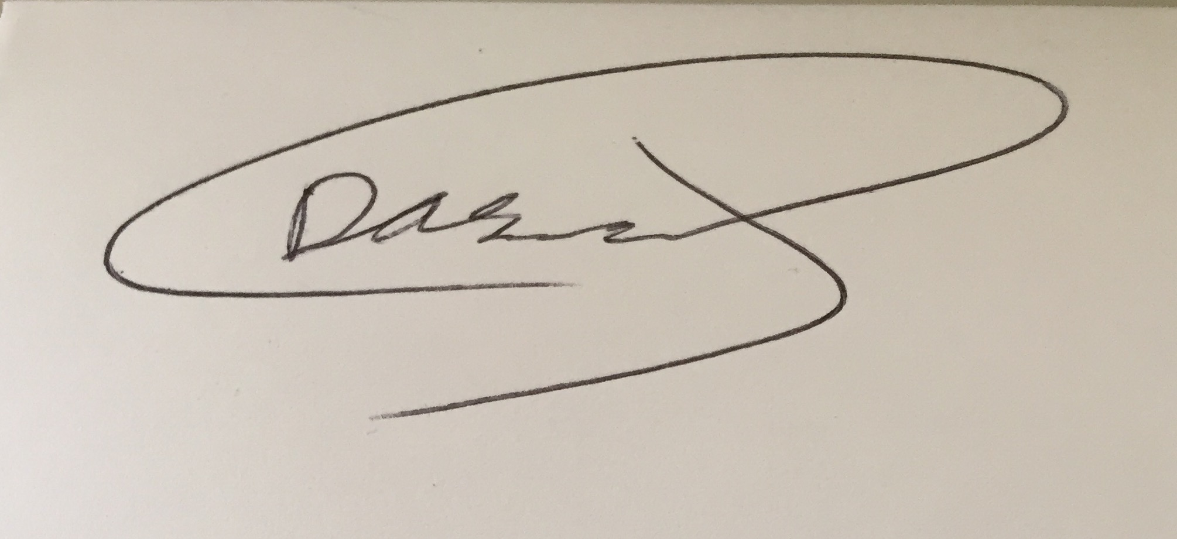
Dashty Jamal
Secretary of the International Federation of Iraqi Refugees (IFIR)

